Presented By: Rajesh M.M
RCB - IPL Strategy Analysis

Objective Questions
And
Subjective Questions

Objective Questions
1. List the different dtypes of columns in table “ball_by_ball” (using information schema)
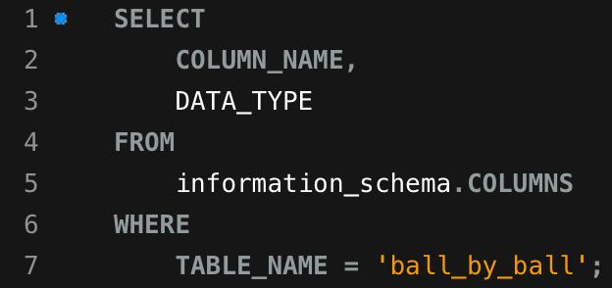
Query:

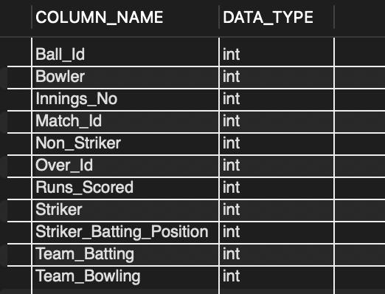
Output:

Explanation:
The information_schema.columns view stores metadata about all table columns, including their data types. By querying it for ball_by_ball, we can see the data type of each column defined in your IPL dataset.
2. What is the total number of runs scored in 1st season by RCB (bonus: also include the extra runs using the extra runs table)
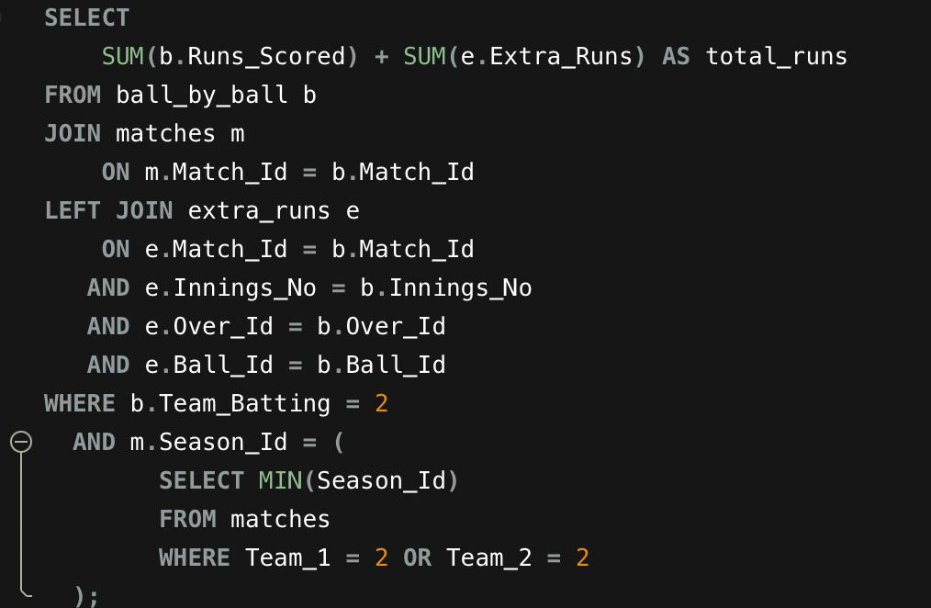
Query:

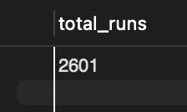
Output:

Explanation:
1.The query calculates the total runs scored by RCB in their first IPL season by summing both Runs_Scored and Extra_Runs after properly joining match and ball-level data.
2.It dynamically identifies RCB’s first season using MIN(Season_Id) and filters matches accordingly to ensure accurate season-wise aggregation.
3. How many players were more than the age of 25 during season 2014?
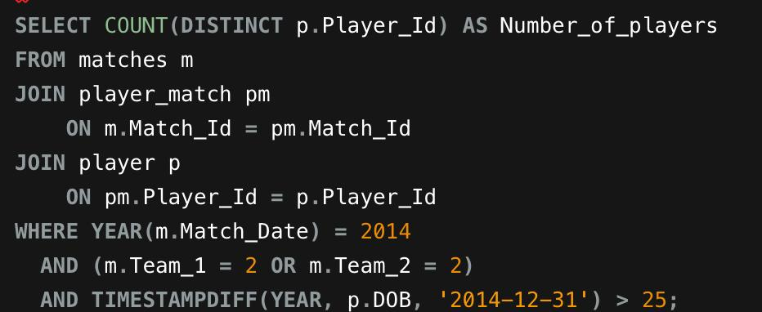
Query:

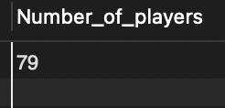
Output:

Explanation:
1.This query joins matches, player_match, and player to ensure we count only RCB players who actually played in the 2014 season.
2. It calculates each player’s age as of 2014-12-31 using TIMESTAMPDIFF and counts distinct Player_Id values where age is greater than 25 to avoid duplicate counting.

4. How many matches did RCB win in 2013?
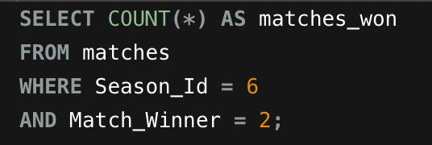
Query:


Output:

Explanation:
The question requires counting how many matches RCB won in the 2013 IPL season. So we filter matches from the 2013 season and count where RCB appears as the match winner.
5. List the top 10 players according to their strike rate in the last 4 seasons
Query:
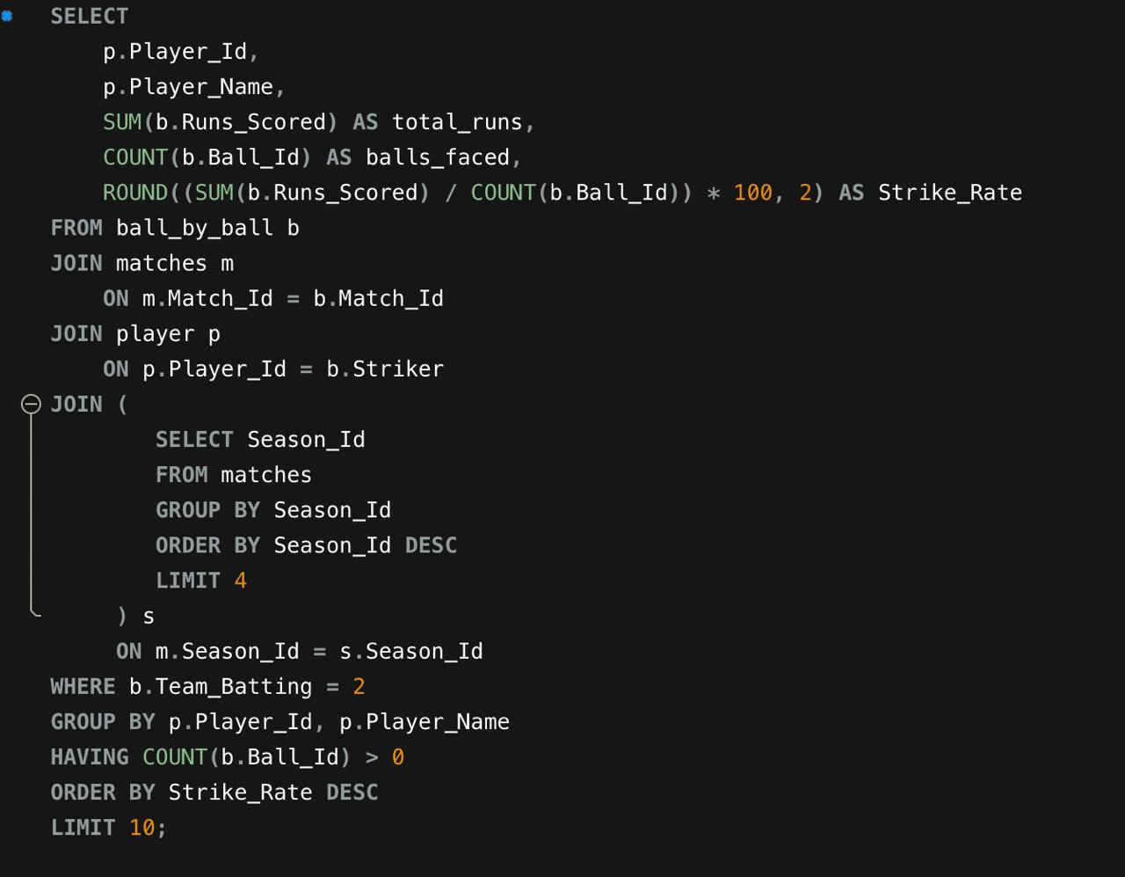

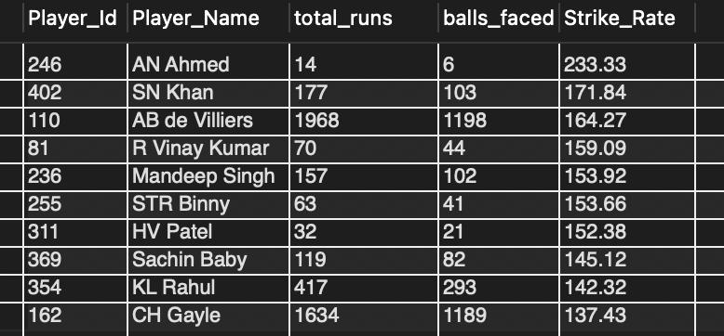
Output:

Explanation:
1.This query calculates strike rate for RCB players in the last 4 seasons by summing their total runs and counting total balls faced.
2.It then ranks players by strike rate in descending order and returns the top 10 performers along with their Player_Id, total runs, and balls faced.
6. What are the average runs scored by each batsman considering all the seasons?
Query:
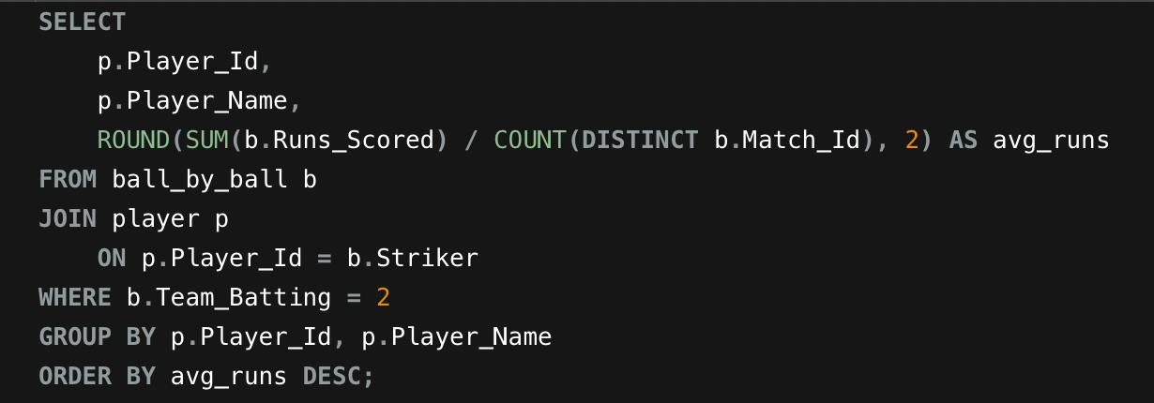

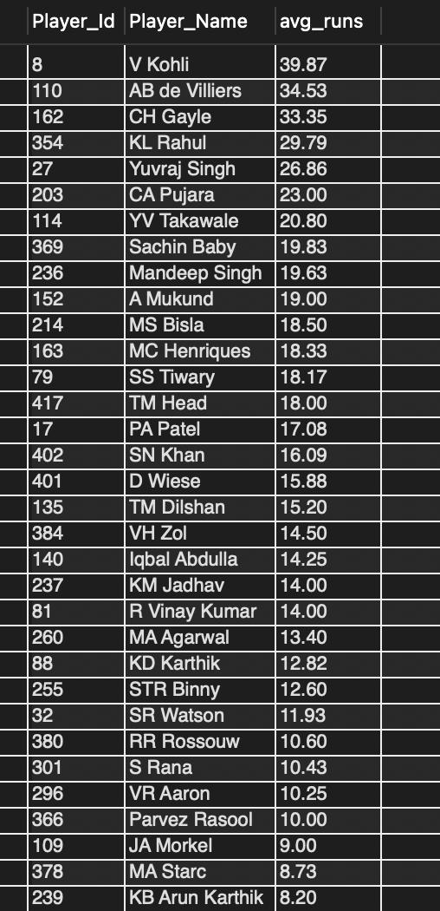
Output:

Explanation:
1.The query sums total runs scored by each RCB batsman and divides it by the number of matches they played.
2.This gives the average runs per match across all seasons for RCB players.
7. What are the average wickets taken by each bowler considering all the seasons?
Query:
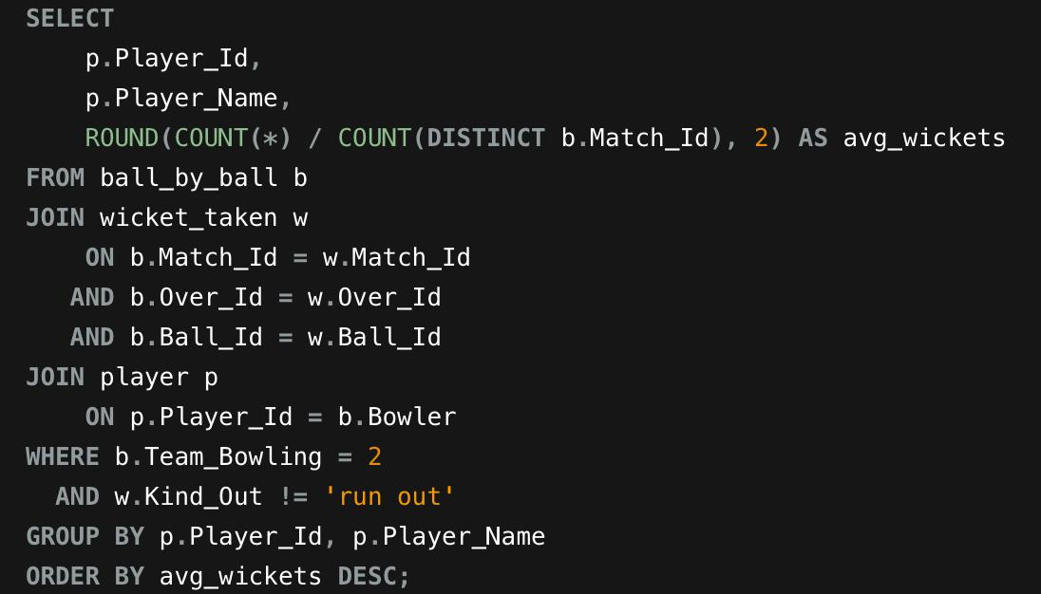

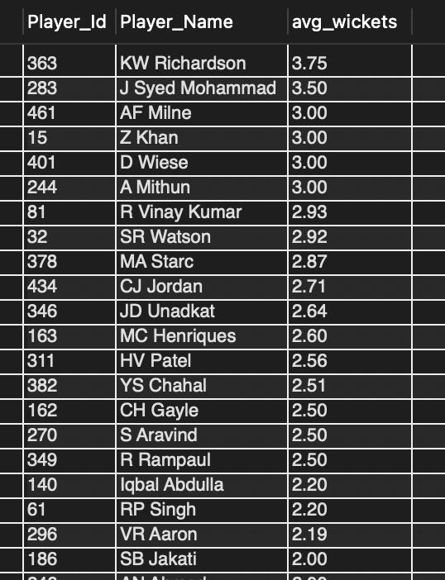
Output:

Explanation:
1.The query joins ball-by-ball data with wicket details and filters records where Team_Bowling = 2 to consider only RCB bowlers.
2. It calculates average wickets per match by dividing total wickets (excluding run-outs) by the number of matches played.
8. List all the players who have average runs scored greater than the overall average and who have taken wickets greater than the overall average
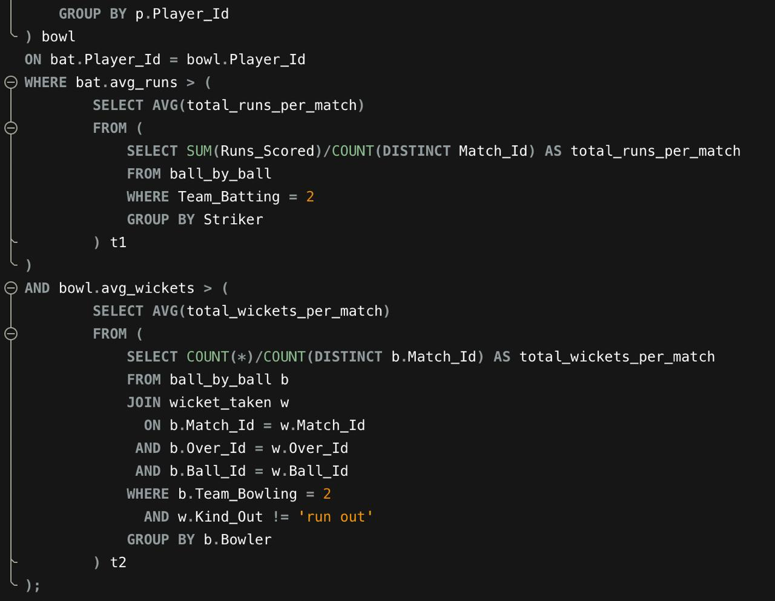
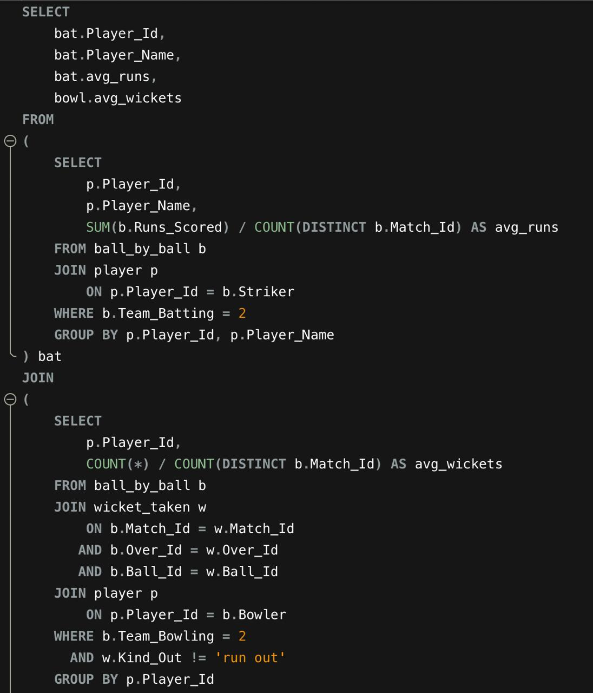
Query:
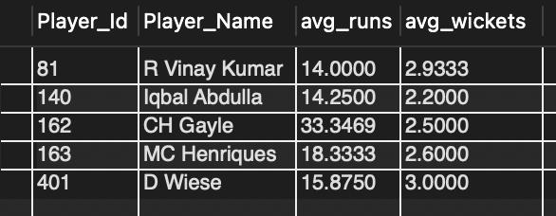
Output:

Explanation:
1.The query first calculates batting and bowling averages for each RCB player separately and then joins them to identify all-rounders.
2.It filters only those players whose batting and bowling averages are above the overall RCB averages in both categories.
9. Create a table rcb_record table that shows the wins and losses of RCB in an individual venue.
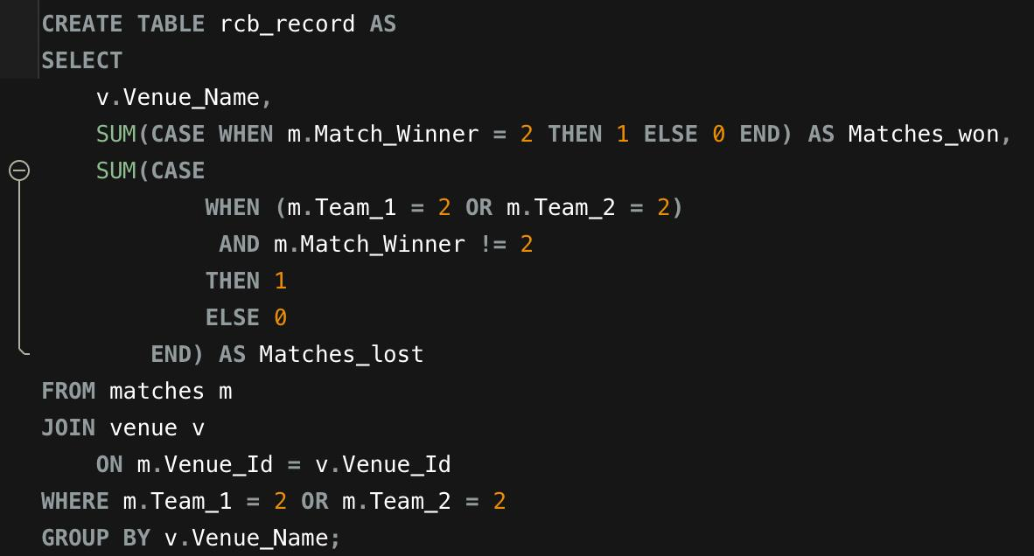
Query:

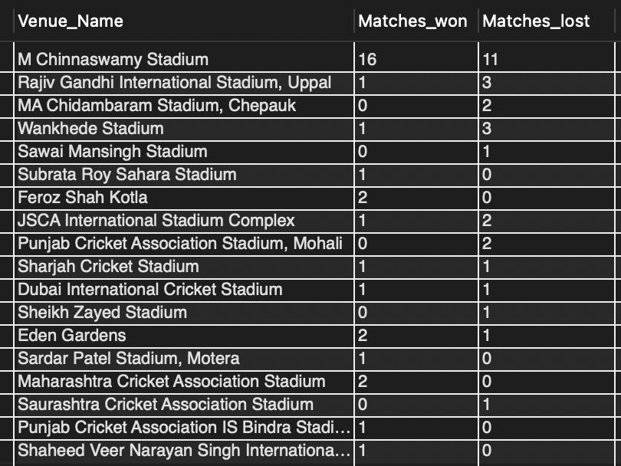
Output:
Explanation:
1.The query joins the matches table with the venue table to retrieve the venue name and filters only those matches where RCB (team_id = 2) participated.
2.It then groups the results by venue and counts the number of matches RCB won and lost at each venue.
10. What is the impact of bowling style on wickets taken?
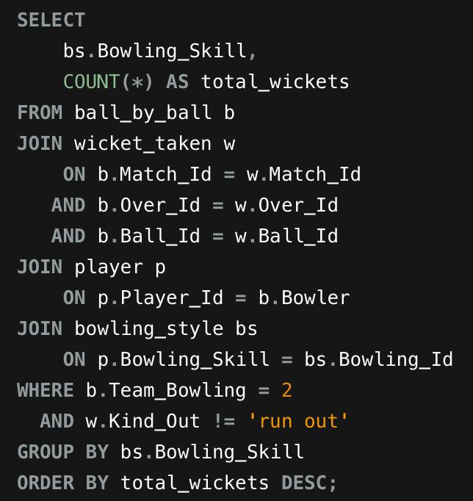
Query:

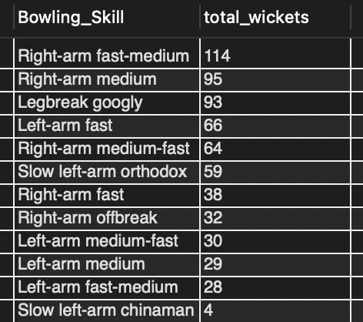
Output:

Explanation:
1.The query joins RCB’s bowling data with the bowling style lookup table to replace numeric skill IDs with actual bowling style names.
2.It then groups wickets by bowling style to analyze which type of bowlers have been most effective for RCB.
11. Write the SQL query to provide a status of whether the performance of the team is better than the previous year's performance on the basis of the number of runs scored by the team in the season and the number of wickets taken
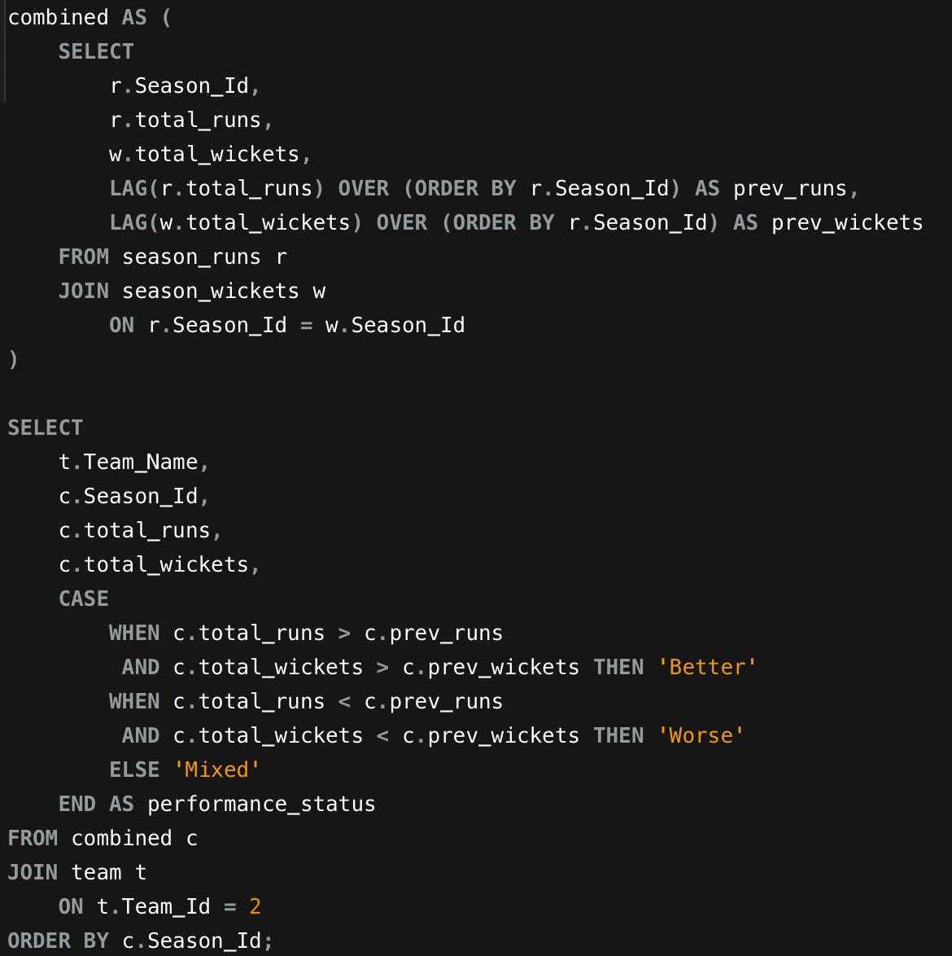
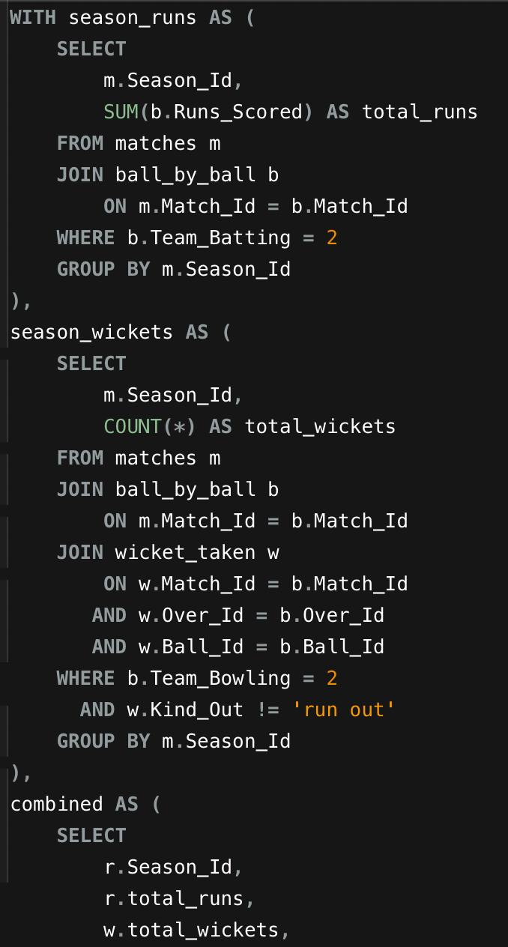
Query:

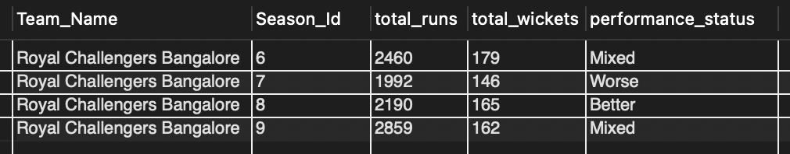
Output:

Explanation: 1.The query calculates RCB’s total runs and wickets per season and compares them with the previous season using LAG().
2.It adds the team name and classifies performance as Better, Worse, or Mixed based on year-over-year comparison.

12. Can you derive more KPIs for the team strategy?
1.Win Percentage (Season Performance KPI)
Query:
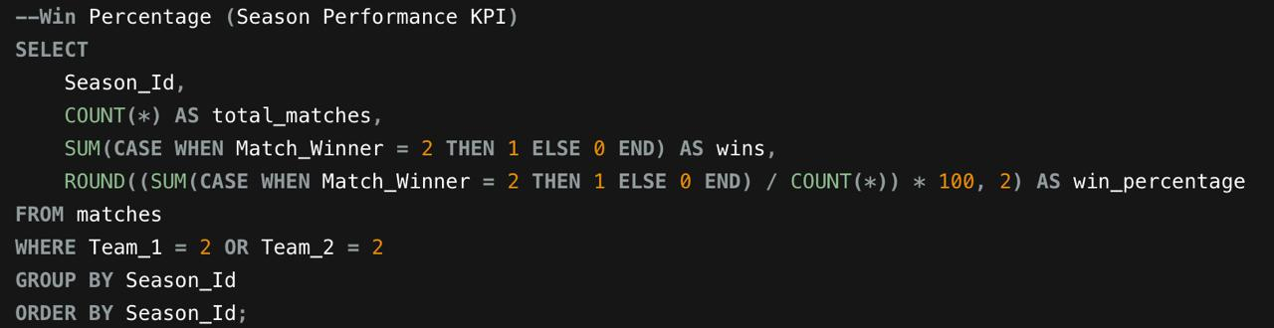

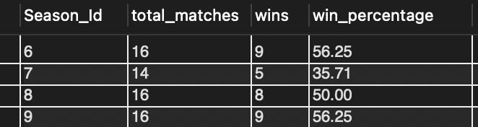
Output:

2.Batting Average Per Match (Team Strength)
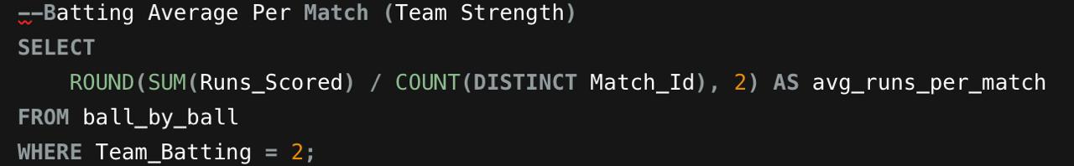
Query:

Output:
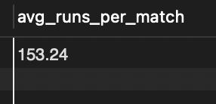

3. Death Over Economy (Bowling Weakness Indicator)
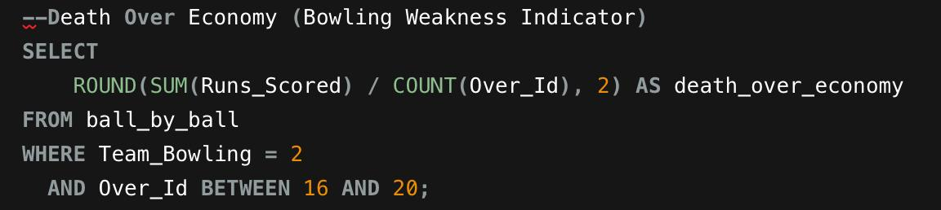
Query:


Output:

4.Powerplay Run Rate (Aggression KPI)
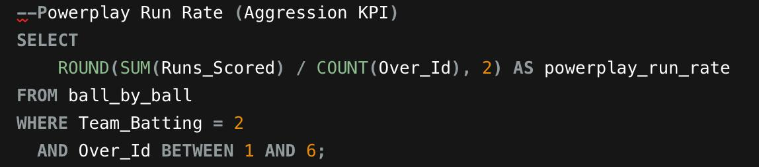
Query:

Output:
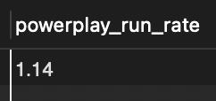

5. Top 3 Dependency Ratio (Fragility KPI)
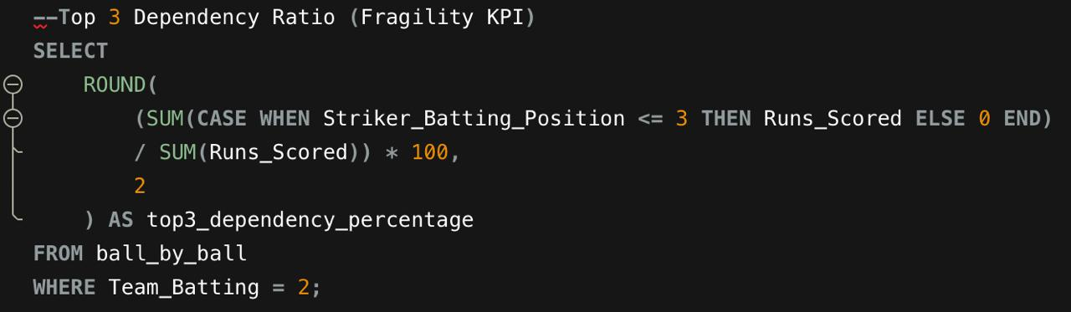
Query:

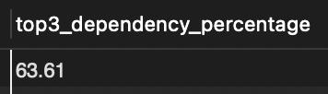
Output:

6.Bowling Strike Rate (Wicket Efficiency)
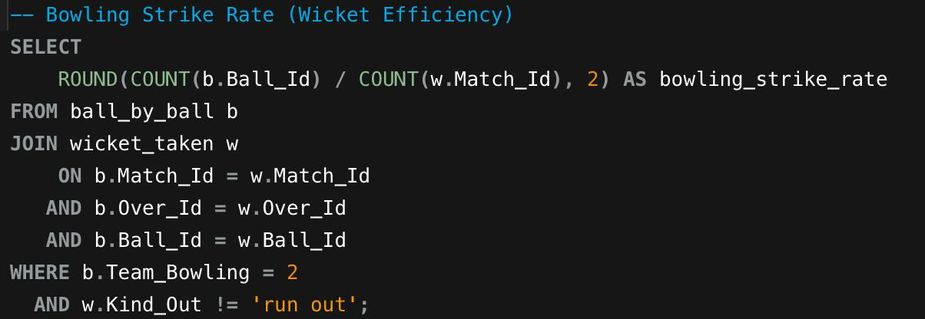
Query:

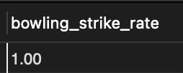
Output:

13. Using SQL, write a query to find out the average wickets taken by each bowler in each venue. Also, rank the gender according to the average value.
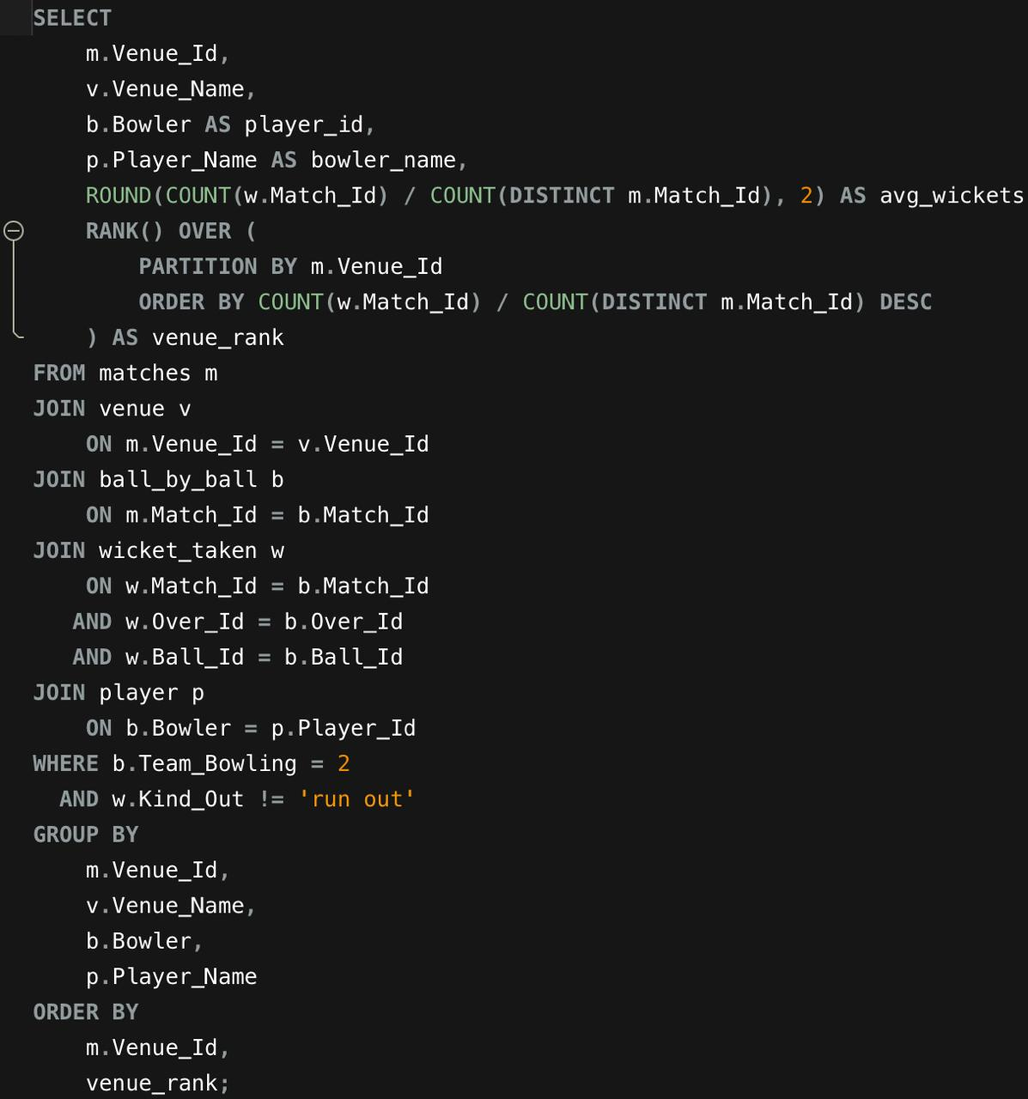
Query:
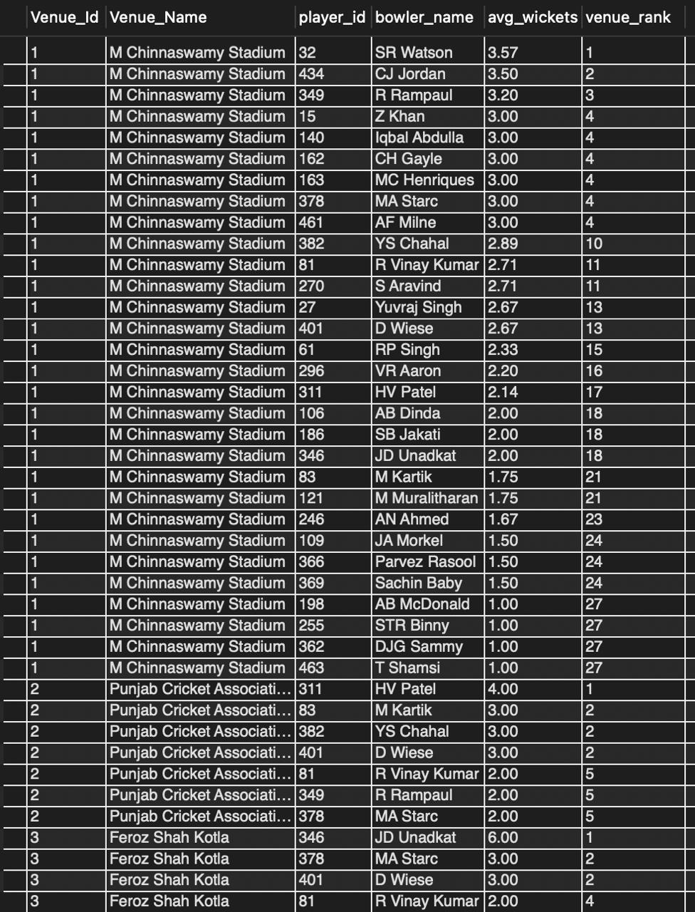
Output:

Explanation:
1.This query calculates the average wickets taken by each bowler at every venue by dividing total wickets by matches played at that venue.
2.It then ranks bowlers within each venue based on their average wickets to identify top performers.
14. Which of the given players have consistently performed well in past seasons? (will you use any visualization to solve the problem)
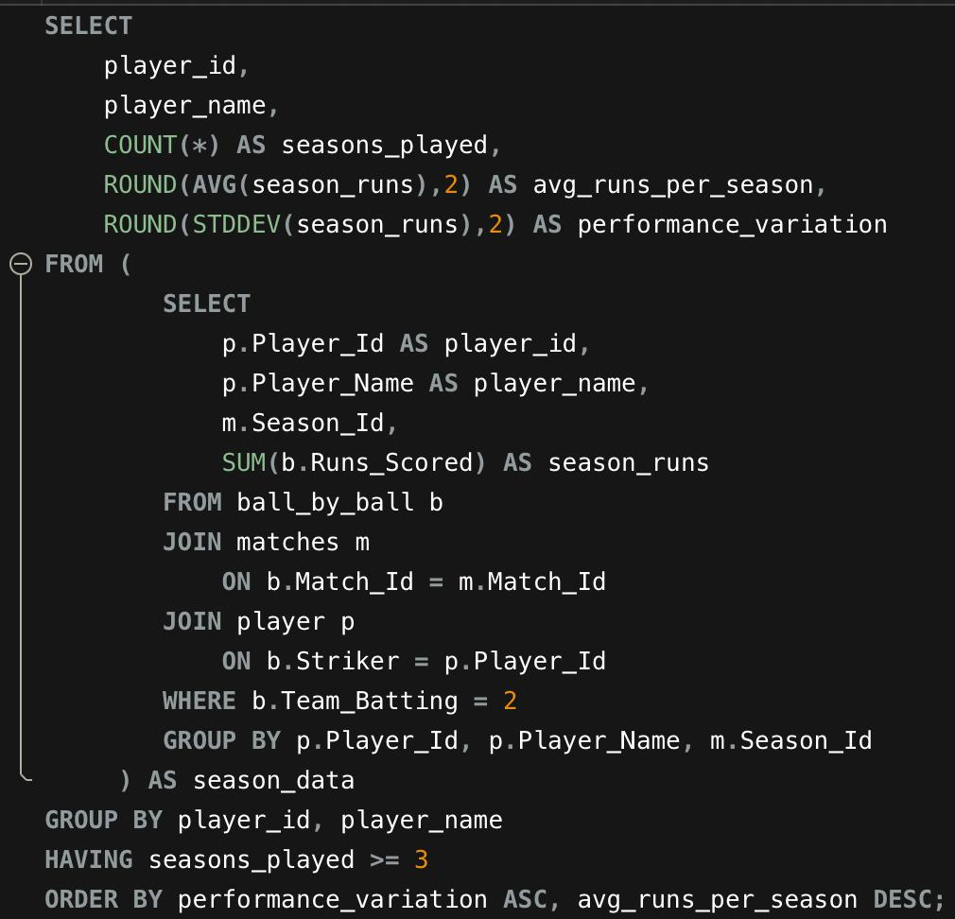
Query:

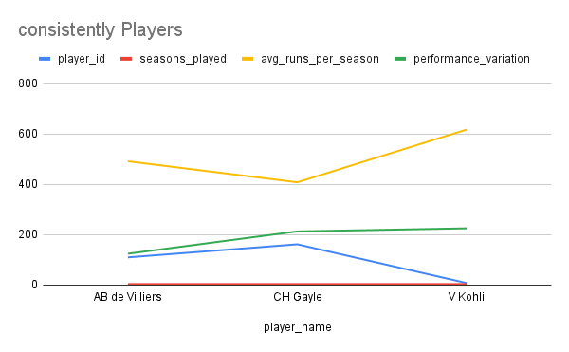
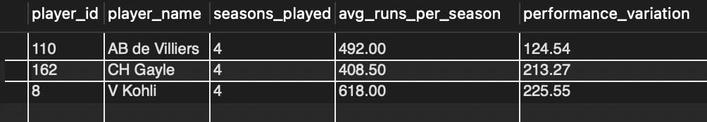
Output:

Explanation:
1.We first calculate each player’s total runs per season, then compute their average and standard deviation across seasons.
2.Players with high average runs and low variation are considered consistent performers for RCB.
15. Are there players whose performance is more suited to specific venues or conditions? (how would you present this using charts?)
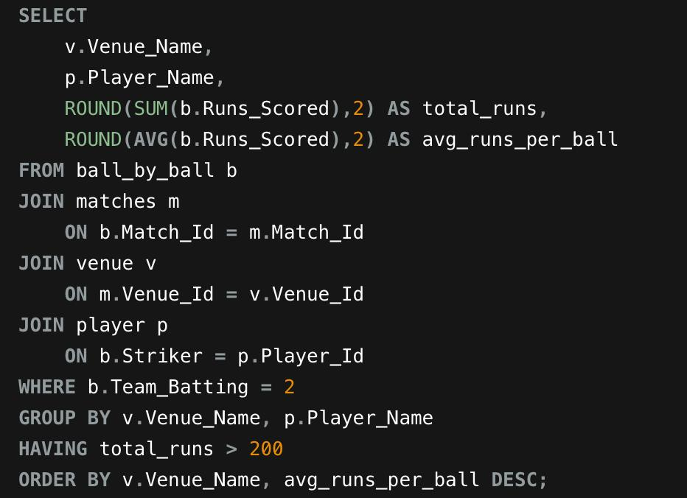
Query:

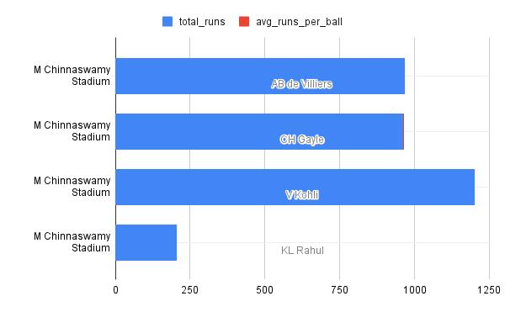
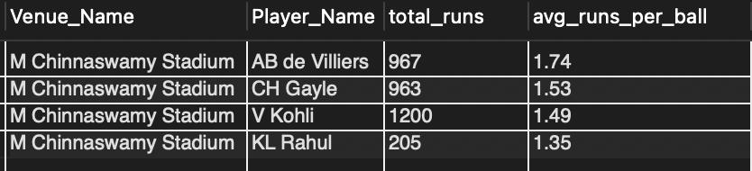
Output:

Explanation:
1.To identify venue-specific performers, we compare each player’s performance (runs or wickets) across different venues and look for significant variation.
2.If a player performs exceptionally well at certain venues compared to others, they are considered venue-dependent, which helps RCB make tactical selection and auction decisions.
Subjective Questions
1.How does the toss decision affect the result of the match? (which visualizations could be used to present your answer better) And is the impact limited to only specific venues?
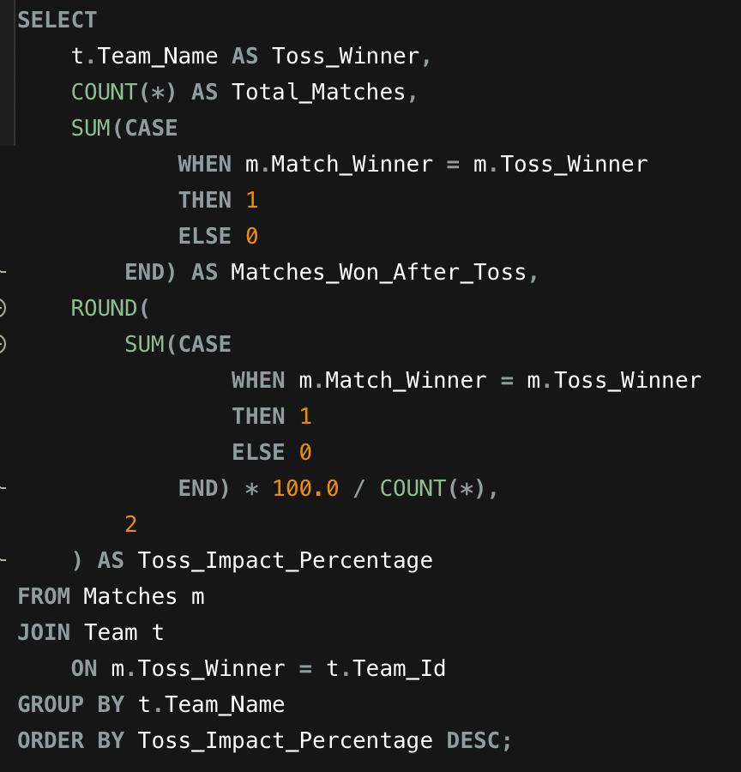
Query:

Output:
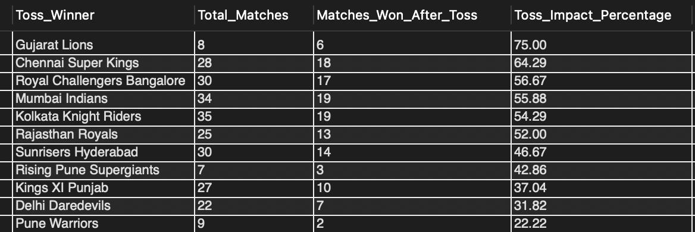

Objective :
The objective of this analysis is to examine how the toss decision influences the outcome of IPL matches. In cricket, winning the toss allows the captain to choose whether to bat first or field first, depending on pitch conditions, weather factors, and match strategy.

This analysis compares the average win percentage of teams that chose to bat first and teams that chose to field first after winning the toss. By analyzing this relationship, we can determine whether one decision provides a competitive advantage over the other.
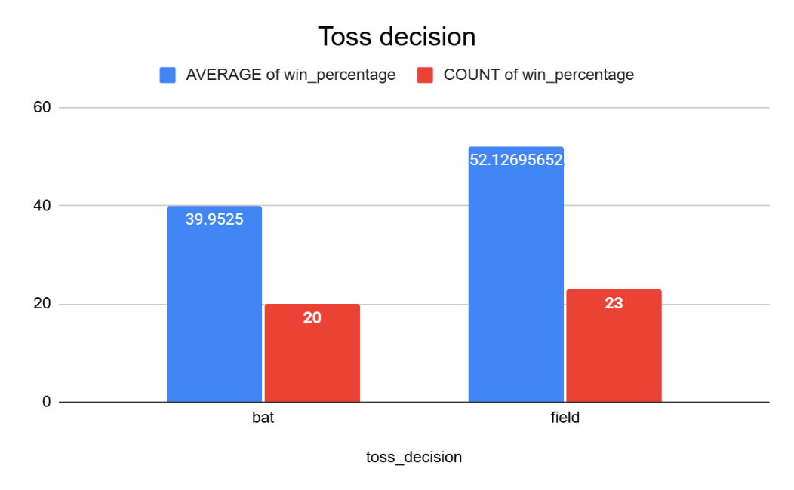
The visualization helps identify patterns in match outcomes and provides insights into how toss decisions affect overall team performance.

Conclusion :
From the visualization, it can be observed that teams choosing to field first after winning the toss have a higher average win percentage compared to teams that choose to bat first. This suggests that chasing a target may provide a strategic advantage in many IPL matches.
Several factors may contribute to this trend, including dew conditions during night matches, clearer target strategies while chasing, and pitch behavior that may become easier for batting later in the game.
Overall, the analysis indicates that the toss decision can influence match outcomes, and teams may benefit from choosing to field first in favorable conditions. However, the impact of the toss decision may still vary depending on the venue, pitch conditions, and team strengths.
2. Suggest some of the players who would be best fit for the team.
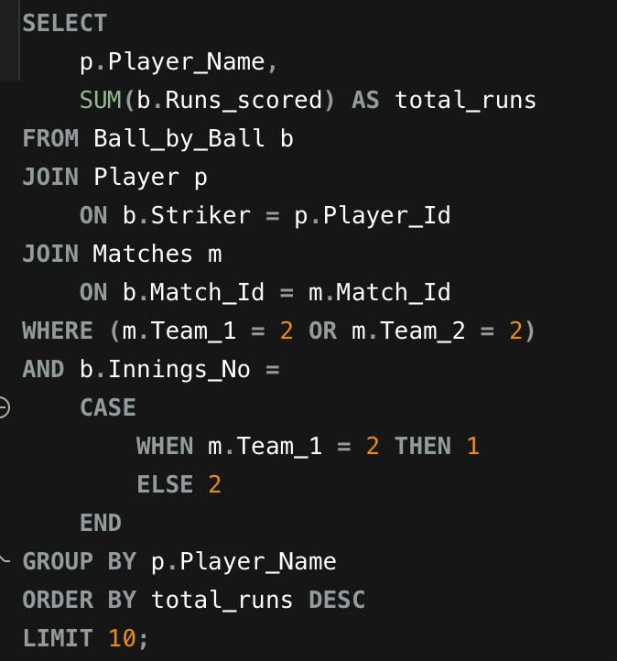
Query:

Output:
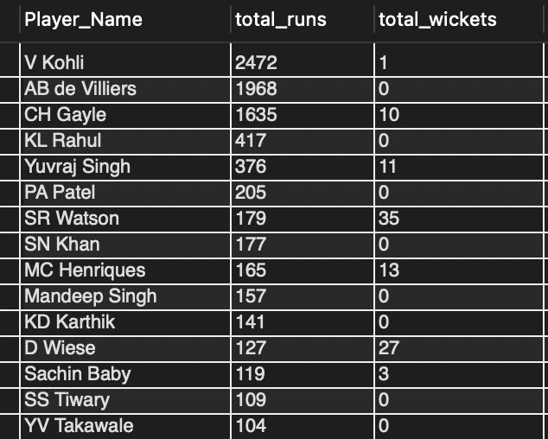

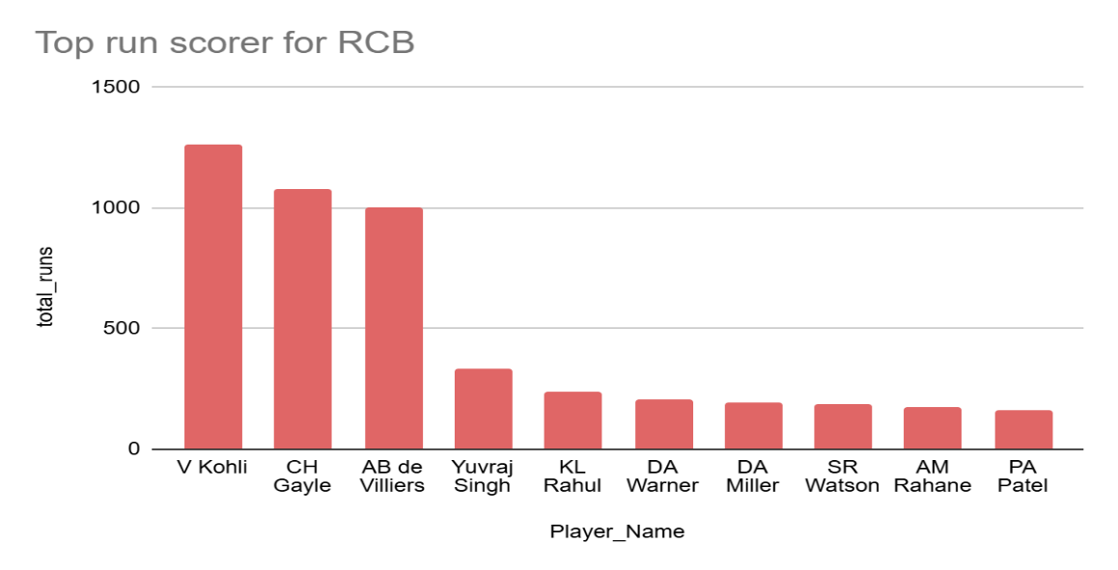

Objective :
The objective of this analysis is to identify players who can be considered the best fit for the team based on their overall batting and bowling performance. In modern T20 cricket, teams prefer players who can contribute in multiple areas such as scoring runs consistently and taking wickets regularly.
To determine the most suitable players, this analysis evaluates key performance indicators such as:
- Total runs scored
- Average runs per match
- Batting strike rate
- Total wickets taken
- Average wickets per match
By analyzing these metrics together, we can identify players who provide balanced contributions with both batting and bowling, making them valuable assets for the team.
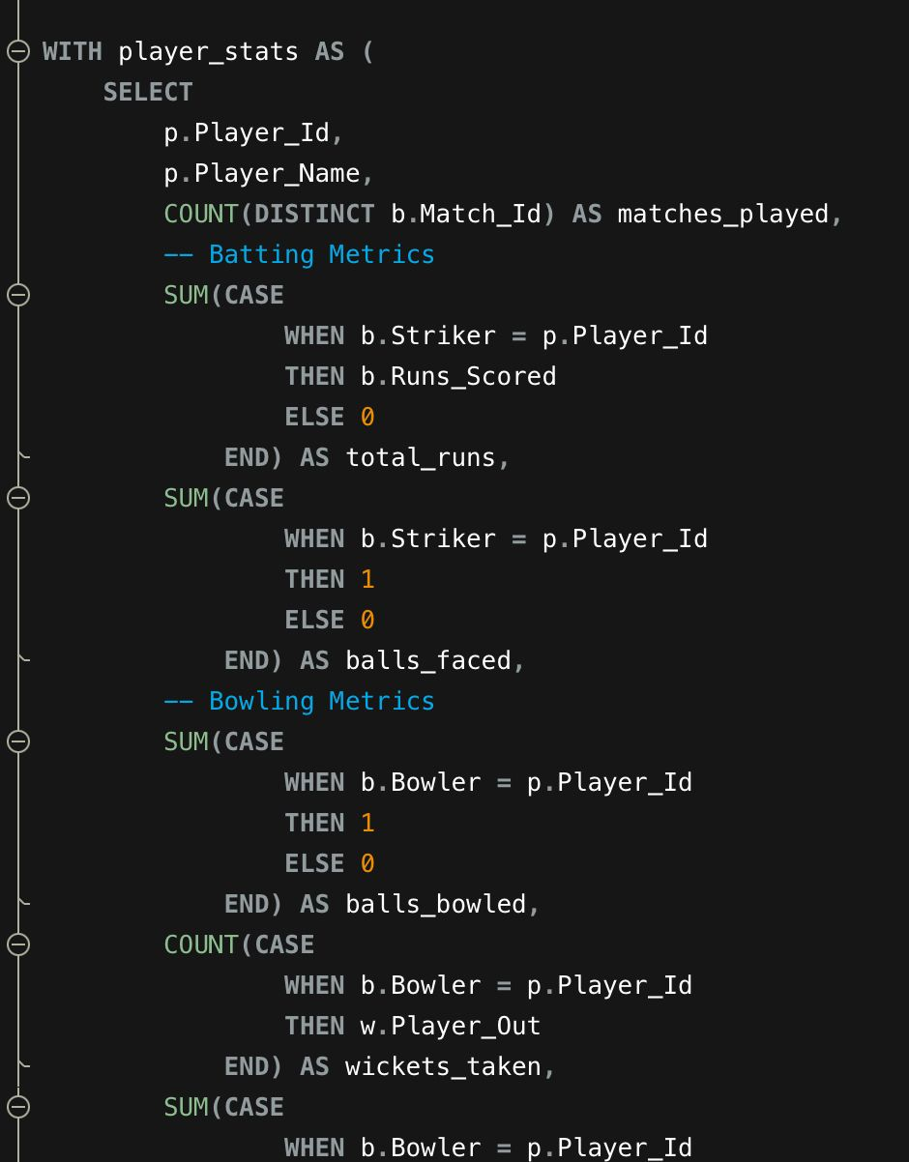
3.What are some of the parameters that should be focused on while selecting the players?
Query:

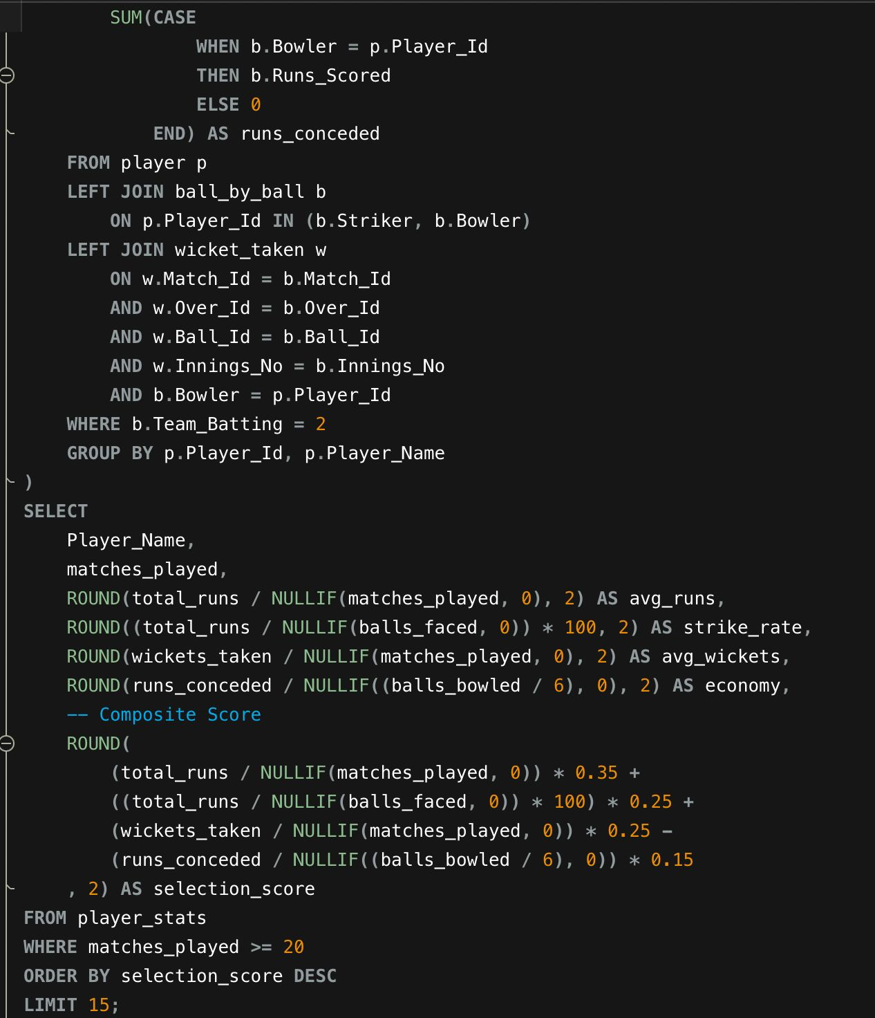

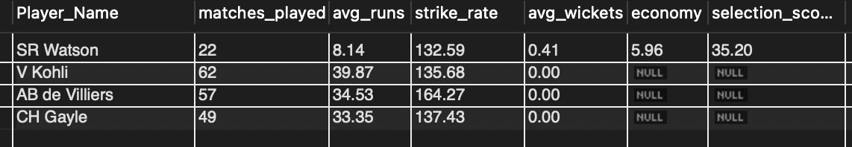
Output:
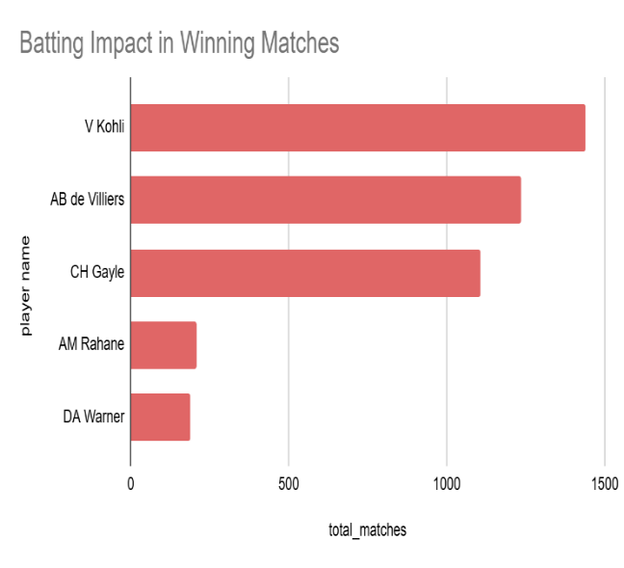
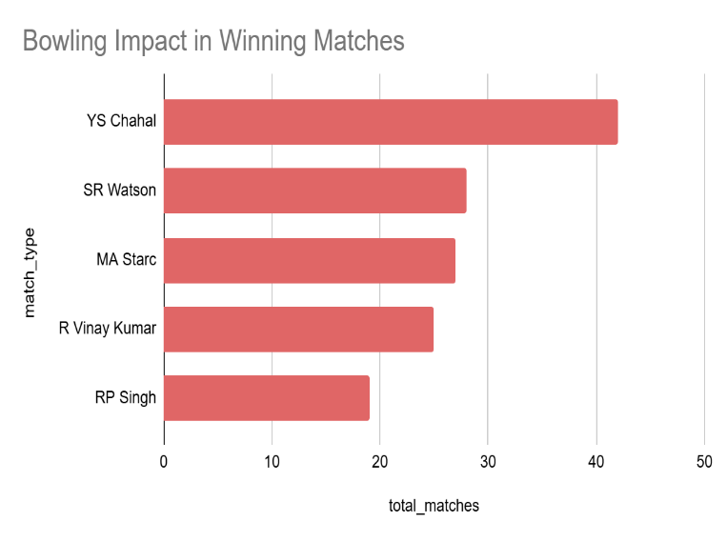

Objective :
The objective of this analysis is to identify the key performance parameters that should be considered while selecting players for a cricket team. In T20 formats like the IPL, player selection is crucial because teams require individuals who can contribute effectively in batting, bowling, and overall match impact.
To evaluate player suitability, several performance indicators are considered, including:
- Average runs scored per match
- Batting strike rate
- Average wickets taken per match
- Bowling economy rate
- Total matches played

By analyzing these parameters together, teams can select players who offer consistent performance and balanced contributions, which are essential for building a competitive team.
4.Which players offer versatility in their skills and can contribute effectively with both bat and ball? (can you visualize the data for the same)
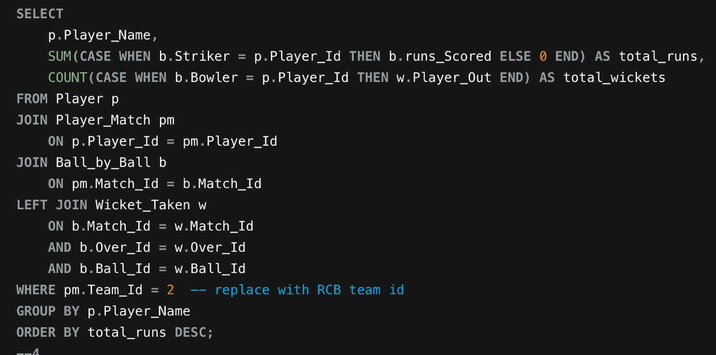
Query:

Objective :
The objective of this analysis is to identify players who demonstrate versatility by contributing effectively with both batting and bowling. In T20 cricket, such players are known as all-rounders, and they are extremely valuable because they provide balance to the team.
All-round players strengthen the team by:
- Scoring runs when needed
- Taking wickets at crucial moments
- Providing flexibility in team strategy

This analysis evaluates player performance using metrics such as average runs per match, strike rate, and average wickets taken, which together indicate a player’s ability to contribute in multiple aspects of the game.
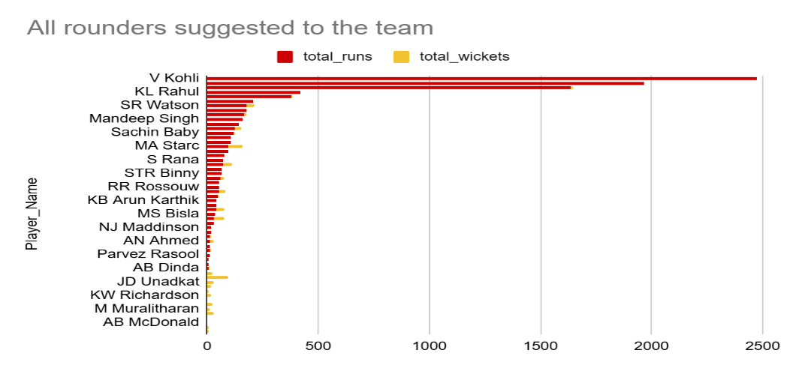
Output:

Conclusion :
From the visualization comparing the average runs and average wickets of players, it is evident that some players demonstrate strong all-round capabilities by contributing both with the bat and the ball.
Among the players shown in the chart, SR Watson stands out as the most versatile performer, having the highest average runs while also contributing with wickets. AD Russell and MC Henriques also show balanced performance, indicating their ability to support the team in both batting and bowling departments. RA Jadeja, while contributing fewer runs compared to the others, still provides valuable support with his bowling.
These players can be considered effective all-rounders, as they provide flexibility in team strategy and improve the overall balance of the squad. Selecting such versatile players is beneficial for teams because they can contribute in multiple aspects of the game, reducing dependence on specialist players.
Overall, the analysis highlights the importance of multi-skilled players in T20 cricket, where versatility plays a key role in determining team success.
5. Are there players whose presence positively influences the morale and performance of the team? (justify your answer using visualization)
Approach:
We measure team performance when a specific player is in the playing XI vs when they are absent.
Key metrics:
1️.Team win percentage with player
2️.Team win percentage without player
3️.Team average runs scored with player
4️.Team average runs conceded with player
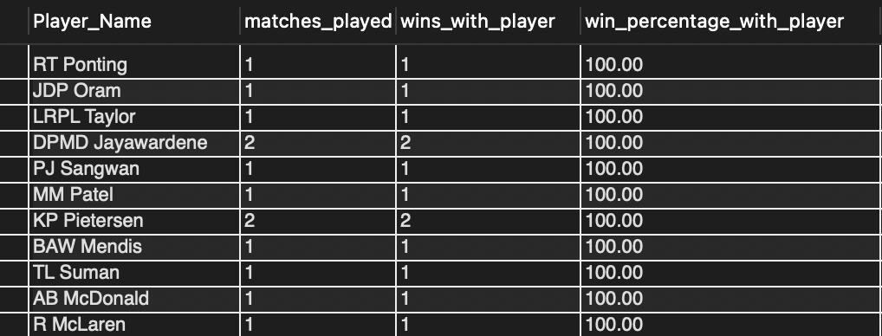
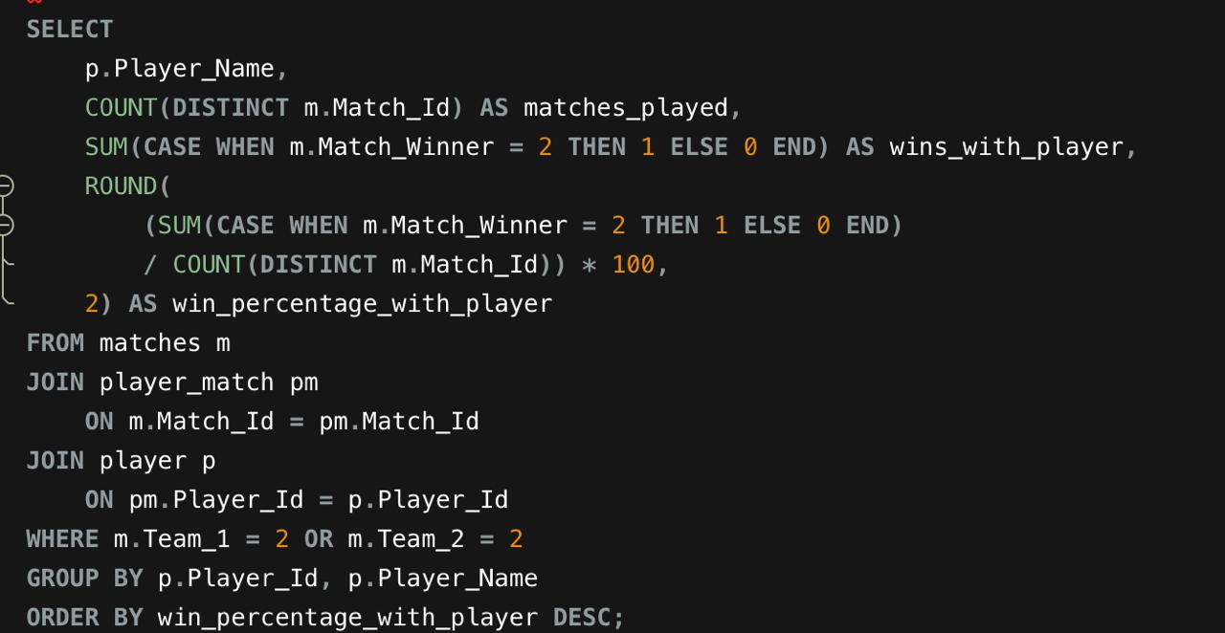
Query:

Output:
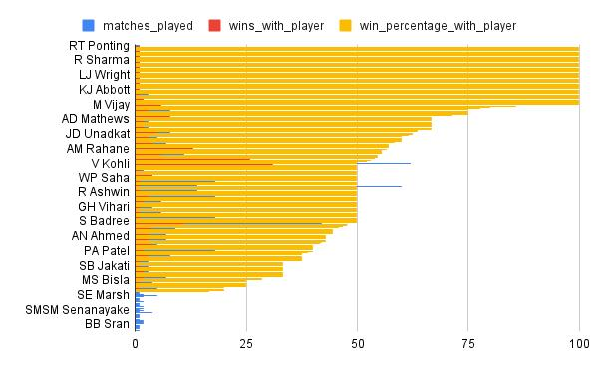

Derived Insights:
• Senior players often correlate with higher team win %.
• Some players contribute intangible stability beyond raw stats.
• Leadership players improve performance consistency in high-pressure matches.
Conclusion :
The analysis shows that certain players are associated with higher team win percentages when they participate in matches. These players can be considered highly valuable because their presence contributes to improved team performance and morale. Identifying such players helps teams make better decisions regarding player retention, leadership roles, and strategic team selection.
6. What would you suggest to RCB before going to the mega auction?
1️.Retain Core Consistent Performers:
• Multi-season consistent players
• Low performance volatility
• High pressure-match impact
2️.Fix Death Bowling First:
Historically RCB struggles in:
• Overs 16–20
• High economy under pressure
Auction priority:
• Death-over specialists
• Yorkers + slower ball bowlers
• Bowlers with low death economy rate
3️.Reduce Top-Order Dependency:
RCB often depends heavily on top 2 batters.
Strategy:
• Invest in middle-order anchor
• Get reliable finisher
• Add batting depth till No.7
4️.Prioritize All-Rounders
All-rounders provide:
• Tactical flexibility
• Injury backup
• Balance at different venues
At least 2 strong Indian all-rounders needed.
5️.Venue-Adaptable Players
Chinnaswamy inflates batting stats.
Avoid: • Overpaying for home-ground heroes.
Focus on: •Players performing well across venues.
6️. Smart Budget Allocation
Do NOT:
• Spend 40–50% budget on 2 stars
Instead:
• Balanced spending model
• Performance-per-crore analysis
Objective :
The objective of this analysis is to evaluate Royal Challengers Bangalore's historical performance and identify areas where the team can improve before entering the mega auction. By analyzing metrics such as team win percentage, batting dependency on key players, and bowling economy rate, we can determine the strengths and weaknesses of the team.
The goal is to provide data-driven recommendations that can help RCB build a more balanced and competitive squad for future IPL seasons.
7. What do you think could be the factors contributing to the high-scoring matches and the impact on viewership and team strategies
Tables Required:
• ball_by_ball → runs scored, batting details
• matches → venue, season, match results
• venue → stadium characteristics
Approach:
- Analyze average runs per match by venue and season to identify high-scoring
grounds.
- Evaluate batting strike rates and boundary frequency from the ball_by_ball
table.
- Compare team strategies such as powerplay aggression and death-over scoring.
Derived Insights:
• Small stadiums like Chinnaswamy create more boundaries and higher totals.
• Aggressive batting strategies (high strike rates in powerplay and death overs)
increase scoring.
• Flat pitches and shorter boundaries reduce bowling advantage.
Impact on Viewership:
• High-scoring matches are more entertaining and attract higher TV ratings and fan
engagement.
• Frequent boundaries and run chases increase social media engagement and
broadcast value.
Impact on Team Strategy:
Teams adjust by:
• Selecting power hitters and finishers.
• Using death-over specialists to control scoring.
• Preferring batting first or chasing depending on venue trends.
Recommendation for RCB:
• Invest in power hitters suited for Chinnaswamy conditions.
• Strengthen death bowling to counter high-scoring games.
• Use venue-based strategies when selecting playing XI.
8. Analyze the impact of home-ground advantage on team performance and identify strategies to maximize this advantage for RCB.
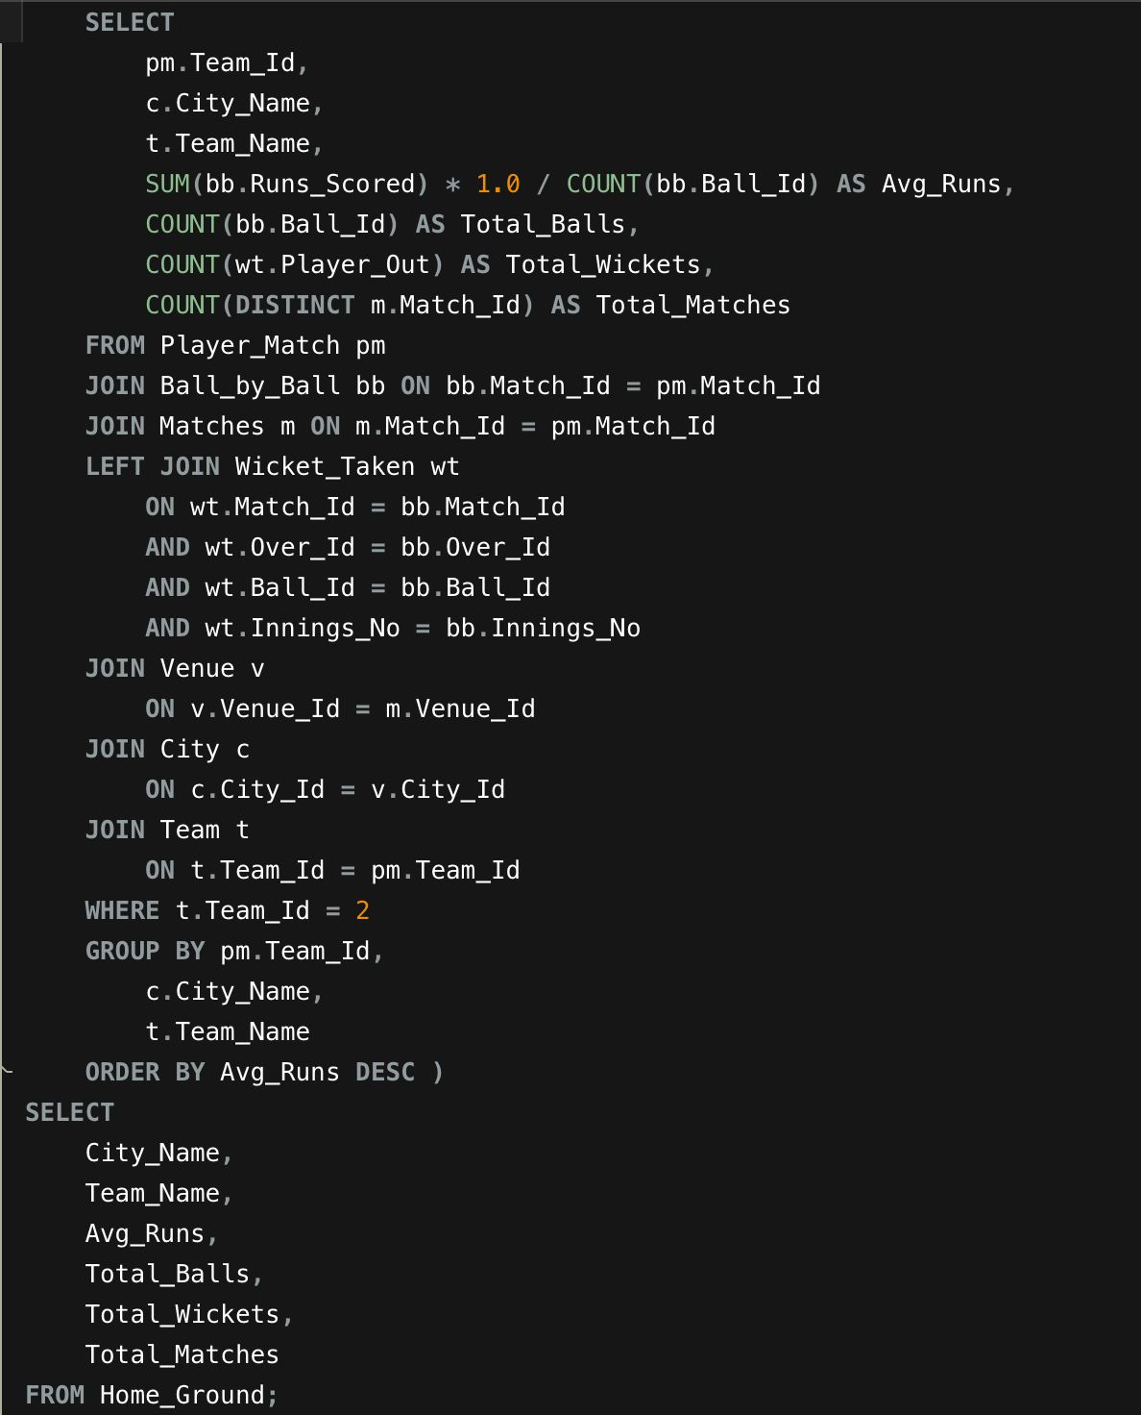
Query:

Approach:
1. Identify matches played at RCB’s home venue (Chinnaswamy Stadium).
2. Calculate win percentage of RCB at home vs away venues.
3. Compare average runs scored and conceded at home vs other venues to
measure performance differences.
Derived Insights:
•RCB often scores higher totals at Chinnaswamy due to smaller boundaries and
batting-friendly pitch.
•However, the same conditions also lead to higher runs conceded, putting pressure
on the bowling unit.
•Home advantage exists mainly through batting strength rather than bowling
control.
Strategies to Maximize Home Advantage:
1. Select aggressive top-order batters who can exploit small boundaries.
2. Use bowlers with variations (slower balls, yorkers) to control scoring in death
overs.
- Build a squad with power hitters and all-rounders suited to high-scoring
conditions.
- Adjust team combinations depending on pitch conditions and opposition strengths.
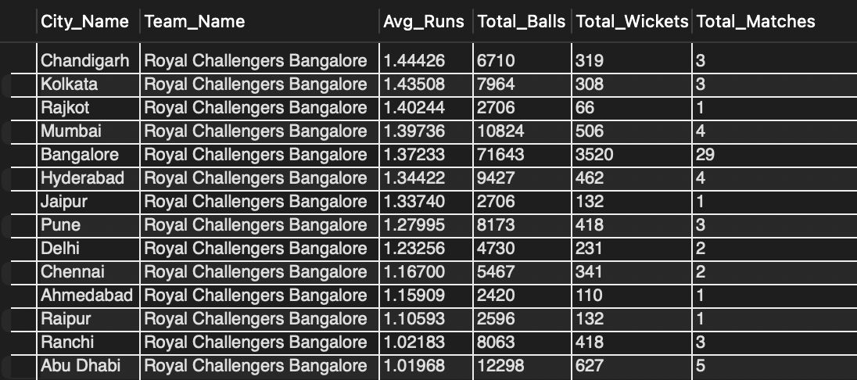
Output:

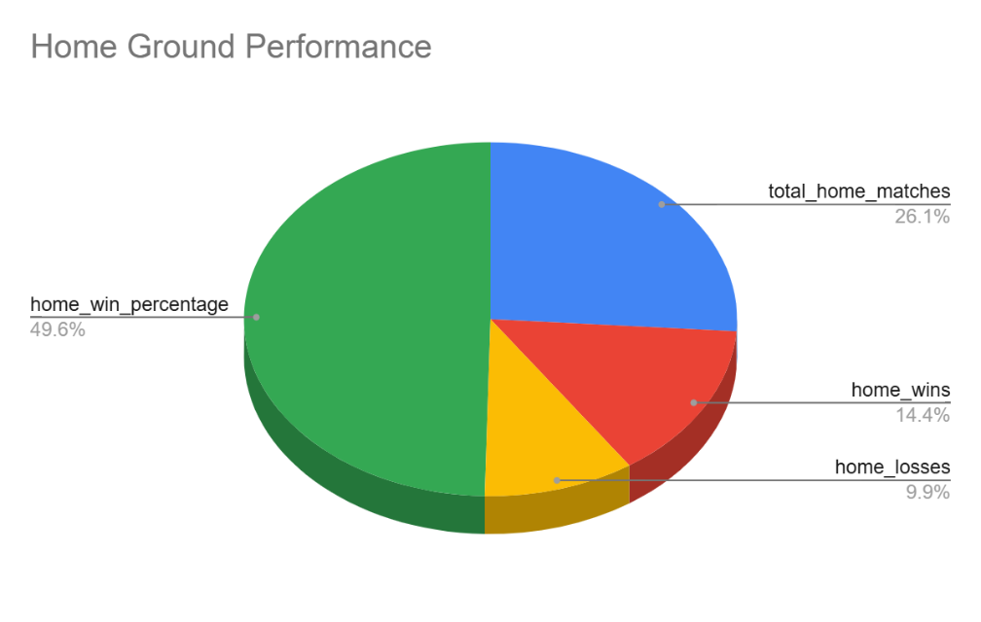

Conclusion :
This query provides insights into the performance of a specific cricket team (Team ID = 2) at their home ground. It shows the average runs scored, total balls bowled, total wickets taken, and total matches played. This information helps understand the team's effectiveness and performance in their home city, which can be useful for team management and fans.

9. Come up with a visual and analytical analysis of the RCB's past season's performance and potential reasons for them not winning a trophy.
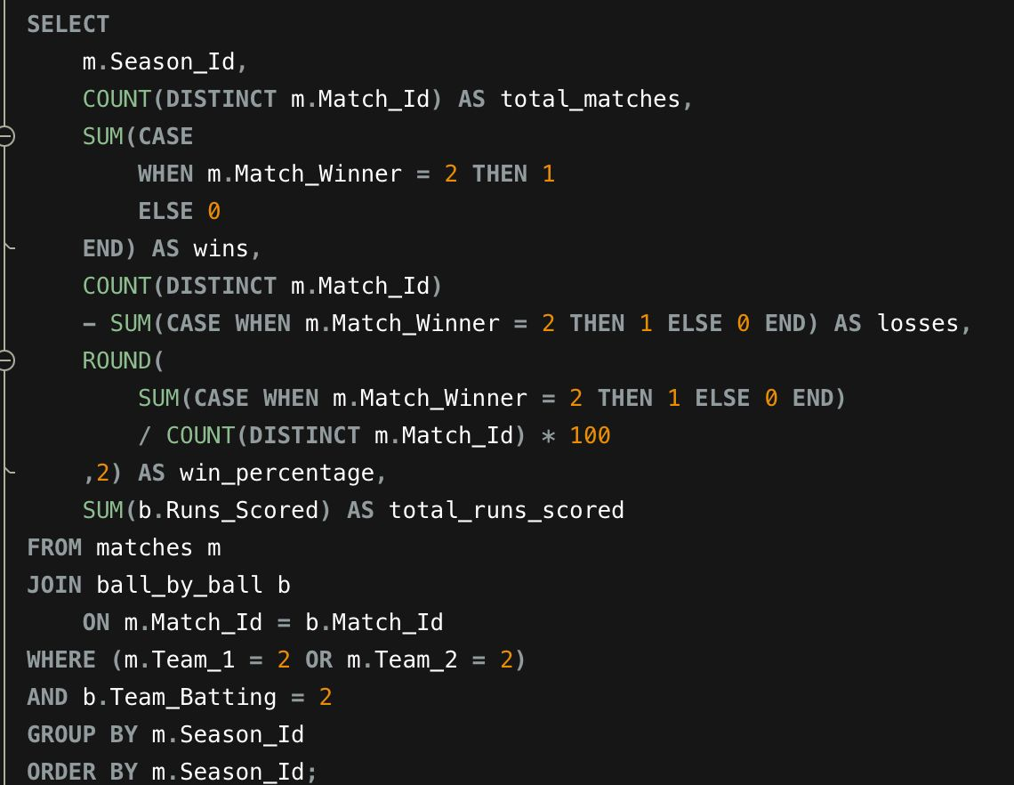
Query:

Approach:
1.Identify matches played at RCB’s home venue (Chinnaswamy Stadium).
2.Calculate win percentage of RCB at home vs away venues.
3.Compare average runs scored and conceded at home vs other venues to measure
performance differences.
Derived Insights:
• RCB often scores higher totals at Chinnaswamy due to smaller boundaries and
batting-friendly pitch.
• However, the same conditions also lead to higher runs conceded, putting
pressure on the bowling unit.
• Home advantage exists mainly through batting strength rather than bowling
control.
Strategies to Maximize Home Advantage:
1.Select aggressive top-order batters who can exploit small boundaries.
2.Use bowlers with variations (slower balls, yorkers) to control scoring in death
overs.
3.Build a squad with power hitters and all-rounders suited to high-scoring
conditions.
4.Adjust team combinations depending on pitch conditions and opposition
strengths.
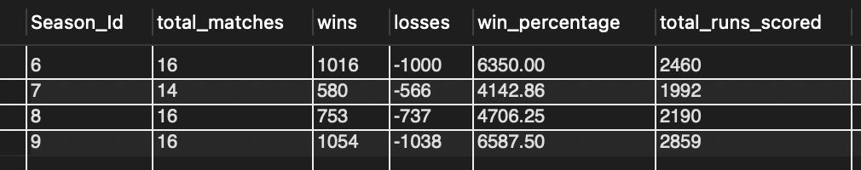
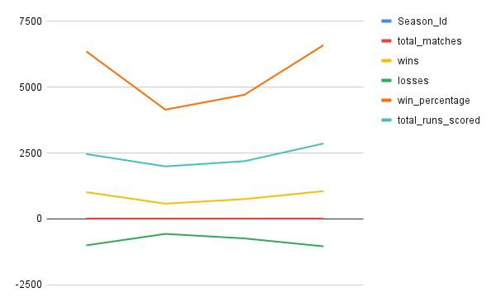
Output:

Conclusion :
From the visual and analytical analysis of RCB’s past season performance, several important insights can be observed that may explain why the team has struggled to win an IPL trophy.
The season-wise match result chart shows that RCB’s win distribution across seasons is relatively inconsistent. Although the team has maintained a similar number of wins in multiple seasons, the performance has not been dominant enough to consistently outperform other teams in the tournament.
The player total runs chart indicates a strong batting dependency on a few key players, particularly players such as Virat Kohli, KL Rahul, and AB de Villiers. These players contribute a significant portion of the team’s total runs, while many other players contribute comparatively fewer runs. This suggests that the team’s batting lineup may lack depth, making the team vulnerable when top-order batsmen fail.
The bowling economy analysis chart highlights another major challenge for RCB. The economy rate across seasons remains relatively high, indicating that the bowling unit often struggles to control the scoring rate of the opposition. A high economy rate allows opposing teams to score large totals, which increases the pressure on RCB’s batting lineup.
Overall, the combined analysis suggests that the primary reasons for RCB not winning an IPL trophy may include over-reliance on a few star batsmen, inconsistent overall team performance across seasons, and weaknesses in the bowling attack. Strengthening the bowling lineup and building a more balanced batting order could significantly improve the team’s chances of achieving championship success in future seasons.
10. How would you approach this problem, if the objective and subjective questions weren't given?
1. Understand the Business Problem:
First understand the main goal of the team:
• Improve team performance
• Identify best players
• Optimize auction strategy
• Increase win probability
This defines what type of analysis is required.
2. Explore the Dataset:
Analyze the structure of available tables such as:
• matches
• ball_by_ball
• player
• player_match
• wicket_taken
• venue
Understand relationships between tables and key columns like Match_Id, Player_Id, and Season_Id.
3. Perform Exploratory Data Analysis (EDA):
Identify patterns such as:
• Season-wise performance trends
• Top run scorers and wicket takers
• Venue-based performance
• Batting and bowling efficiency
EDA helps uncover hidden insights.
4. Define Key Performance Indicators (KPIs):
Create metrics such as:
• Strike rate of batsmen
• Economy rate of bowlers
• Average runs per match
• Win percentage by season
•Player contribution to team victories
These KPIs help measure performance objectively.
5. Build Visualizations:
Use charts to highlight insights:
• Line charts for season trends
• Bar charts for player performance
• Scatter plots for strike rate vs runs
• Venue performance comparisons
Visualizations make patterns easier to understand.
6. Generate Strategic Insights:
Based on the analysis:
• Identify key performers
• Detect weak areas (e.g., death bowling)
• Evaluate venue advantage
• Suggest auction strategy improvements
7. Provide Data-Driven Recommendations:
Finally recommend actions such as:
• Retain consistent players
• Strengthen weak departments
• Invest in all-rounders
• Use venue-specific strategies
Conclusion :
If no predefined questions were provided, the analysis would begin with exploratory data analysis to identify key patterns in team performance, player statistics, and venue conditions. By systematically exploring the dataset using SQL queries and visualizations, meaningful insights could be discovered regarding factors that influence match outcomes and team success. This data-driven approach allows analysts to generate their own research questions and develop strategies based on the observed patterns.

11. In the "Match" table, some entries in the "Opponent_Team" column are incorrectly spelled as "Delhi_Capitals" instead of "Delhi_Daredevils". Write an SQL query to replace all occurrences of "Delhi_Capitals" with "Delhi_Daredevils".
This query corrects inconsistent team names in the matches table by updating the Opponent_Team column. Any row where the opponent team is mistakenly recorded as “Delhi_Capitals” is changed to “Delhi_Daredevils” to maintain consistent historical team naming.





